**UK firefighters go to Spain for wildfire training as number of blazes surges**

Exclusive: wildfires, once rare in the UK, more than doubled last year to nearly 24,000 with devastating effects on wildlife habitats

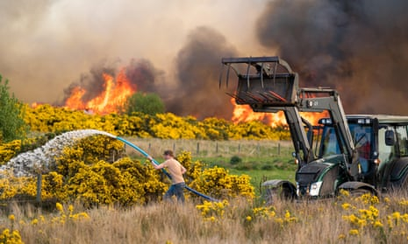

Wildfires recorded by UK fire brigades surged in 2022 amid extreme heat and droughts, new figures show, as a growing number of fire services invest in new equipment to deal with the rising fire risk due to climate change.

Figures obtained by the Guardian under Freedom of Information Act requests show the number of wildfires recorded by fire brigades in England, Wales, [Scotland](https://www.theguardian.com/uk/scotland) and Northern Ireland more than doubled last year, reaching 23,699 in 2022, compared with 9,307 the year before.

Last summer, as temperatures exceeded 40C (104F) for the first time, [damaging blazes swept across](https://www.theguardian.com/uk-news/2022/jul/20/this-doesnt-happen-in-wennington-residents-and-fire-services-reel-after-homes-lost-in-blazes-across-england) the country, burning through homes in Wennington, east London and Barnsley, South Yorkshire. Wildfires burned through crucial habitats for wildlife, such as ground-nesting birds, lizards and snakes, and destroyed forests and other ecosystems that are being restored for climate-change mitigation.

Large wildfires were once rare in the UK. When satellite monitoring started in 2006 through the [EU’s Copernicus system](https://effis.jrc.ec.europa.eu/apps/effis.statistics/estimates), no large fires were recorded for five years until 2011. Since then, 599 large wildfires have been recorded, burning 126,618 hectares (310,000 acres).

From Cornwall to Kent, fire services are now investing in new equipment such as off-road vehicles, drones and backpack sprayers to prepare for hotter summers, as well as equipment to help firefighters cool down while battling blazes.